- The Monetary Policy Committee has indicated it's increasingly worried about the recent weakness in UK employment growth. This week's labour market and business survey data showed further signs that conditions in the jobs market are deteriorating. But we don't expect the MPC will commit to a more rapid pace of rate cuts in the near-term.
- Pay growth remains well above the pace the MPC considers to be consistent with meeting the inflation target, while serious data problems relating to the Labour Force Survey continue to cloud the jobs market outlook. We continue to expect the MPC to tread cautiously and maintain its 'cut-hold' tempo.
In recent years, the focus of the Monetary Policy Committee has been almost entirely on inflation. But the minutes of December's meeting suggested the MPC is starting to place more emphasis on concerns about soft output and employment growth. The release of November's official labour market statistics and January's S&P Global flash PMIs this week provided an opportunity to assess how that growth/inflation trade-off is developing.
The first of those releases was a good example of the trade-off. Headline (three-month average of the annual rate) whole economy pay growth rose to 5.6%, from 5.2% in October. Crucially, this was driven by stronger private sector regular wage growth – the Bank of England's favoured pay measure – which accelerated to 6% from 5.5% a month earlier.
Base effects caused by a particularly weak reading for October 2023 have certainly exaggerated the recent pickup in pay growth. Our proprietary sentiment-based indicator, developed with Penta, has been notably softer than the official data in recent months, suggesting that pay growth has stabilised around the 4.5% mark at the turn of the year (Chart 1). This is still well above the pace the BoE considers to be consistent with meeting the inflation target in the medium-term. But the key question for the MPC is whether pay growth will now slow towards a more target-consistent pace.
Chart 1: Our nowcast suggests pay growth is holding steady at around 4.5%
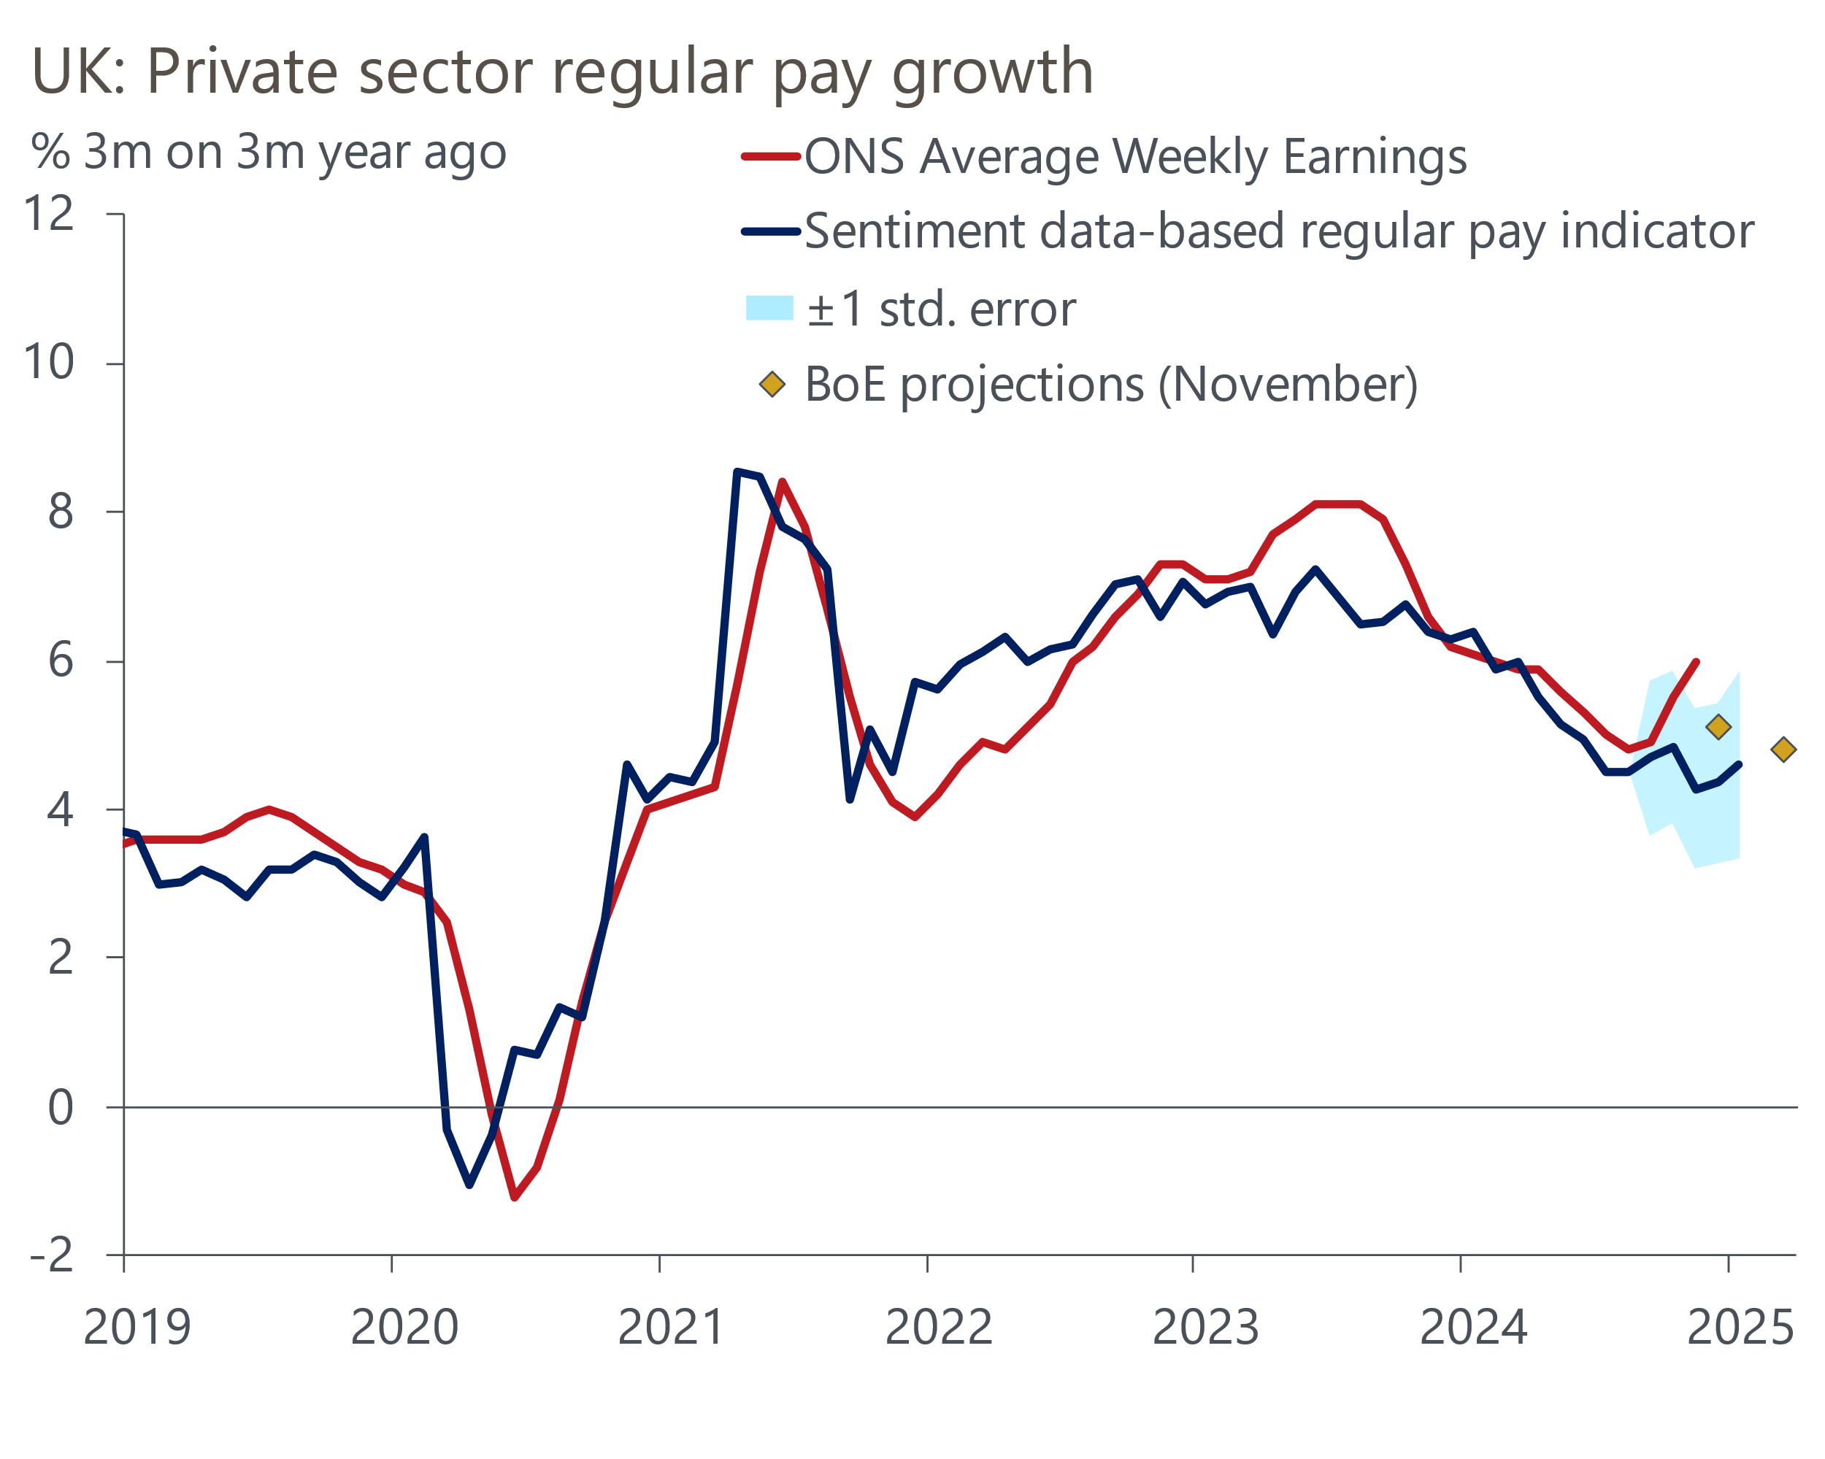
Source: Oxford Economics, Haver Analytics and Penta

In this regard, evidence of cooling labour market conditions would provide the MPC with some reassurance. But, as we set out in a note published this week, serious problems with the Office for National Statistics' flagship Labour Force Survey have left policymakers flying blind. Indeed, the data is so unreliable that we place little weight on news that the unemployment rate ticked up by 0.1ppt to 4.4% in November.
It could be another two years before the overhaul of the LFS has been completed. So it's vital to use other sources of data to gauge the strength of the labour market. Series like HMRC's count of payrolled employees are important in this regard. This week's publication reported that the count of employees fell by 47k in December – the second consecutive large m/m decline.
But it's important to recognise that this series is not without its flaws either. The HMRC series can be subject to substantial revisions, particularly in the first few months after estimates have been published. Furthermore, of late these revisions appear to have an upward bias – first estimates of the m/m change in payrolls were revised up by an average of 42k in 2024 (Chart 2). If this pattern continues, data for late-2024 may not look quite as soft in a few months' time.
Chart 2: HMRC's count of employees has weakened of late, but the series is often heavily revised
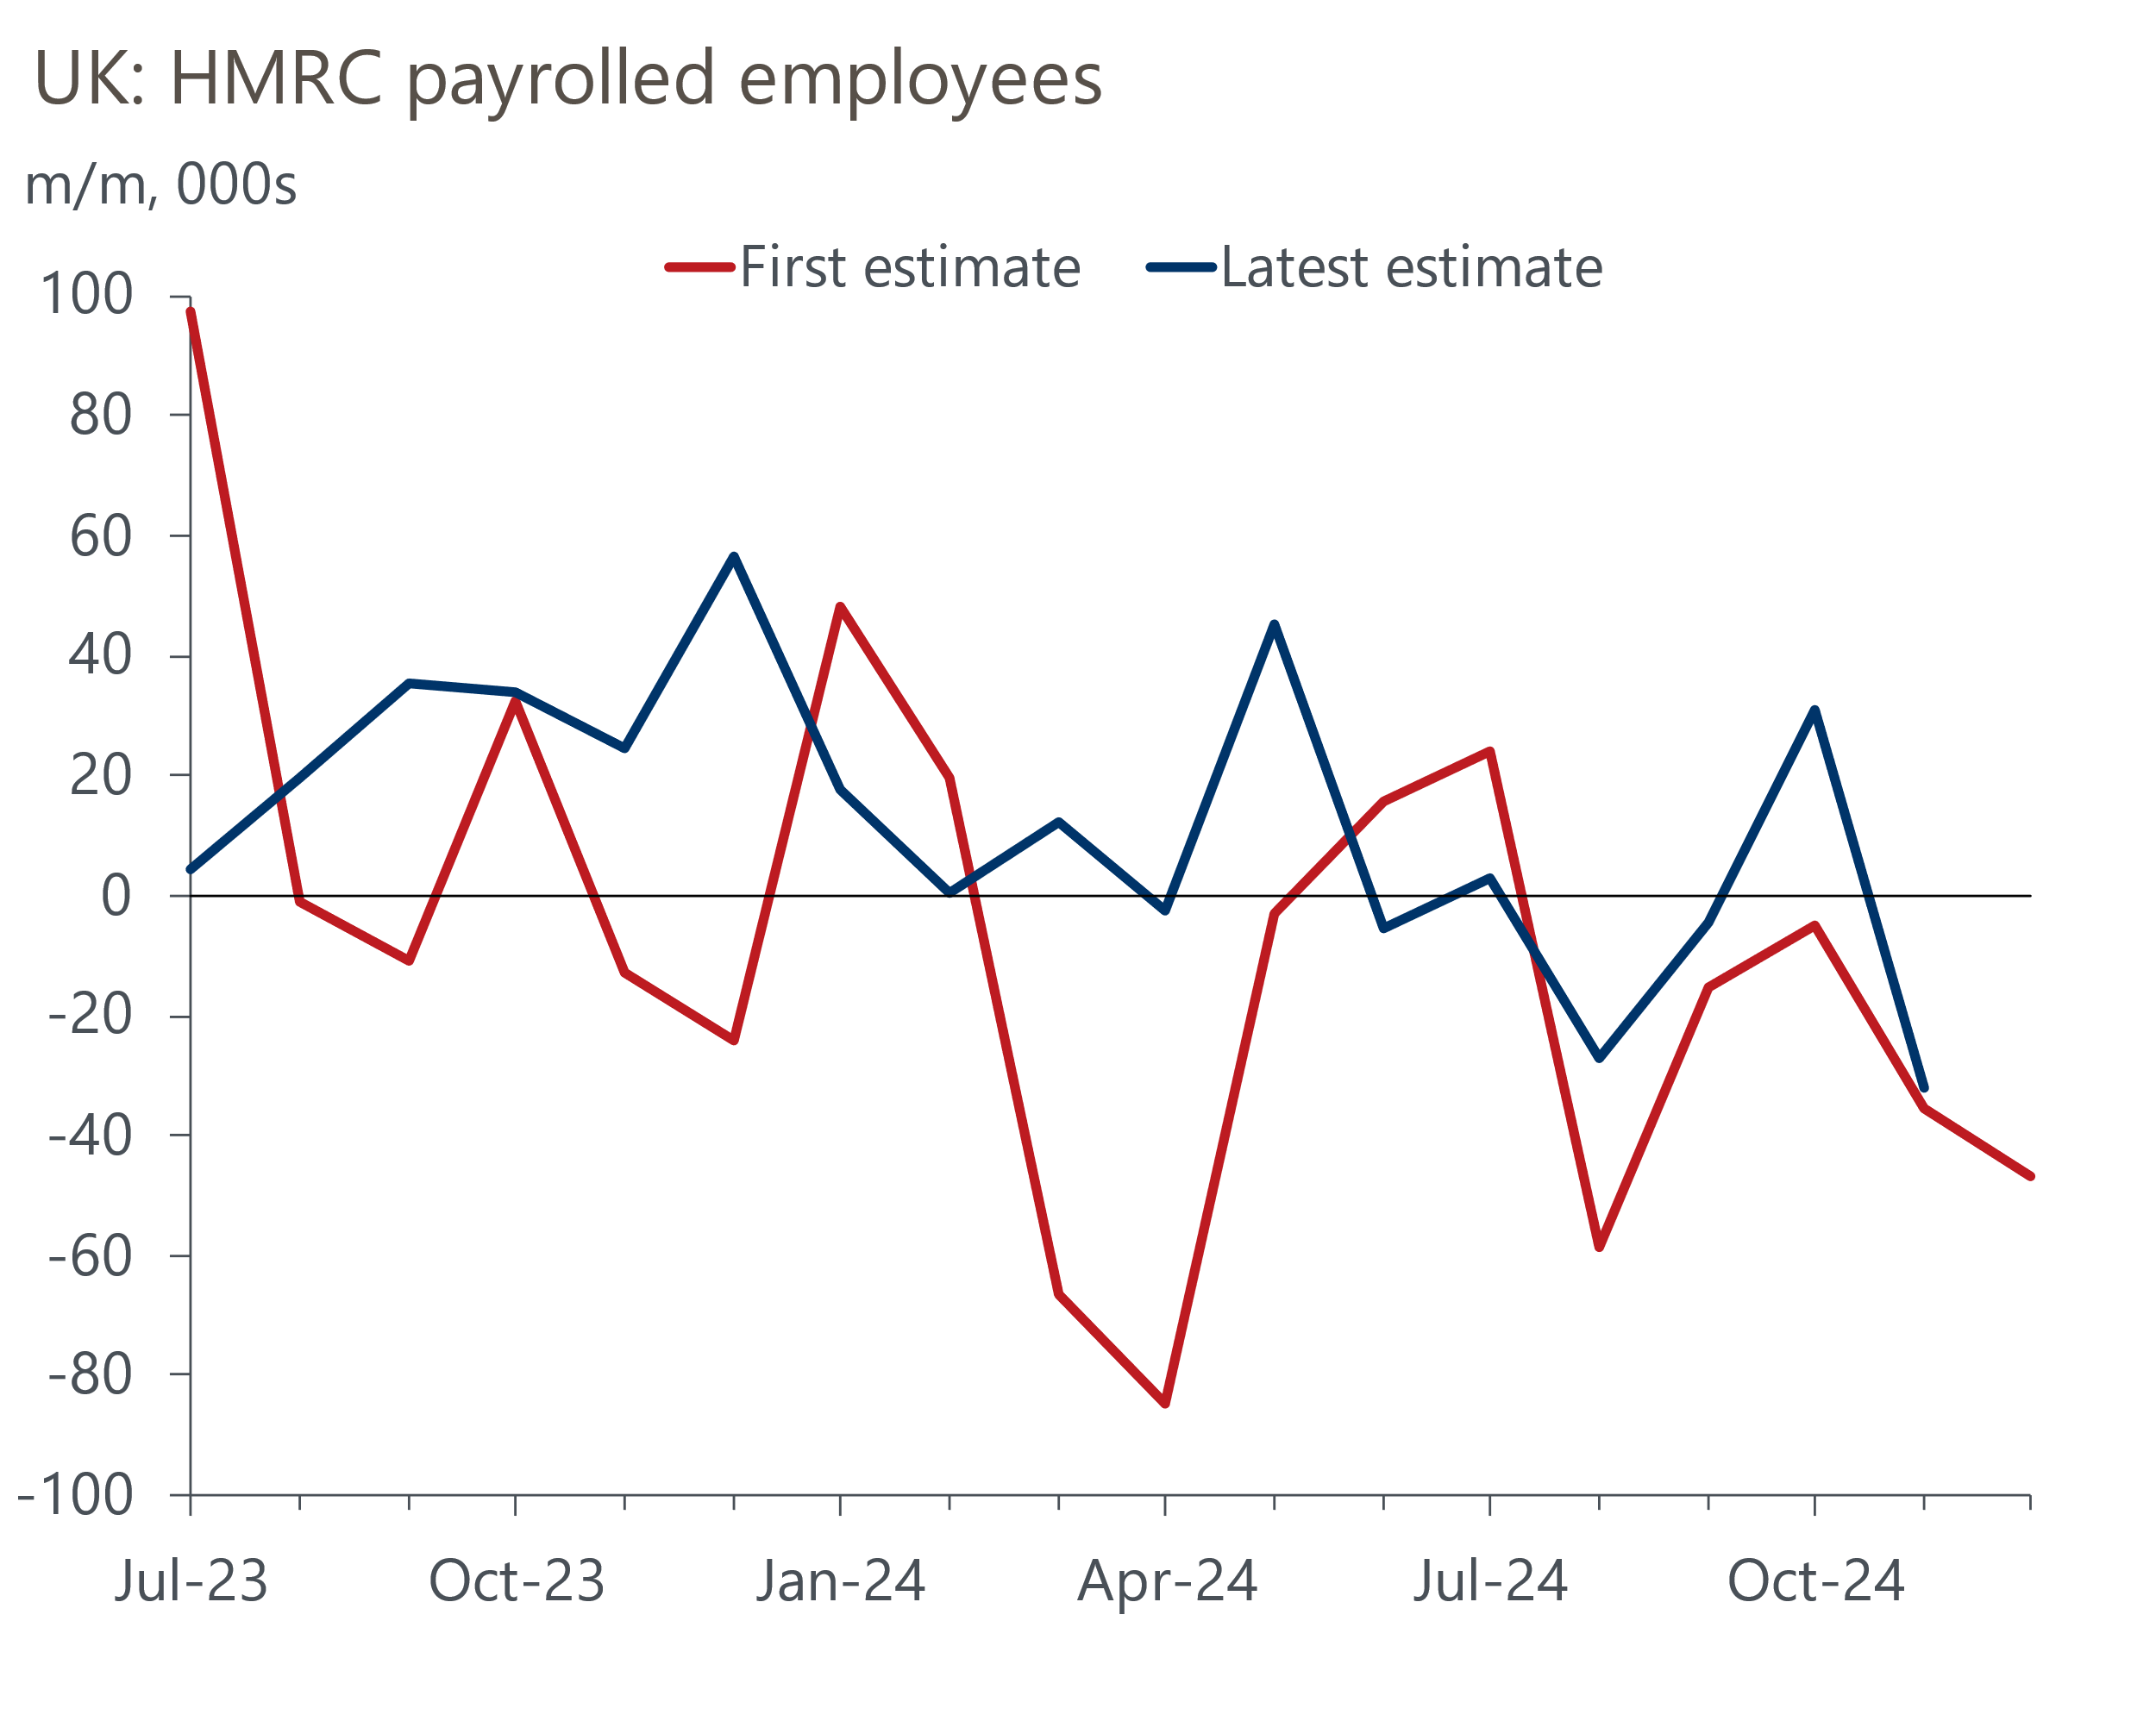
Source: Oxford Economics calculations using ONS & HMRC RTI
Our sentiment-based employment nowcast suggests that year-on-year employment growth dropped to zero around the turn of the year, the weakest reading since mid-2021. This message chimes with other data, most notably the ONS' measure of job vacancies, which fell further in the three months to December. But with the rate of redundancies still very low, firms don't appear to be aggressively reducing headcount yet.
January's S&P Global flash PMI survey also reported that staffing numbers continued to decline due to hiring freezes and the non-replacement of leavers. The flash composite PMI picked up slightly, though it remained below historical norms. But as we've regularly argued in recent months, it's difficult to distinguish the degree to which results reflect swings in sentiment rather than genuine trends in business conditions. Equally, while surveys offer a good indication of the direction of travel, they are often a poor guide to magnitude.
On balance, this week's releases have highlighted the difficult position the MPC currently finds itself in, rather than providing the committee with a clear steer. Pay growth remains relatively sticky, which will reinforce concerns about the second-round effects on inflation. And though some of the quantities data suggested that weaker labour market conditions should increasingly bear down on wage growth, data problems will leave the MPC with more doubt than they would like. So the MPC is likely to stick to a cautious approach to loosening policy in the near-term, maintaining its 'cut-hold' tempo.
Recognising the importance of labour market developments, we've launched a series of Research Briefings on the key issues. Subscribers to our Global Macro Service can access the first two notes on the key uncertainties and the challenges posed by data problems and how they can be mitigated.

The week ahead
The only release of note next week is the Bank of England's Money & Credit data for December. Following a surprise decline in November, we think the upward momentum in mortgage activity resumed in December. We have pencilled in a rise in mortgage approvals to 71,700, from 65,700 in November. But there's some uncertainty around the timing of the peak boost from buyers trying to transact before stamp duty thresholds drop back to normal levels. And given mortgage rates continued to edge up during December, the risks are skewed towards a smaller increase in mortgage activity.
Owing to the time lag between a mortgage being approved and funds being dispensed, solid mortgage demand in early autumn is likely to have supported stronger net mortgage lending in December. Therefore, we anticipate that net mortgage lending rose to £3.6bn, from £2.5bn in November.
On the unsecured side, a sharp rise in repayments more than offset higher gross lending in November. December's soft retail sales outturn suggests gross lending may have weakened slightly. But repayments were at a very high level, so we see scope for this to fall more. As a result, we forecast that net unsecured lending edged up to £1.1bn from £0.9bn in November.
Table 1: Week ahead calendar
Date | Events | Period | Measure | Unit | Previous | Forecast
Jan 30 | Mortgage approvals | Dec | Level | 000s | 65.7 | 71.7
Jan 30 | Mortgage lending | Dec | Net lending | £bn | 2.5 | 3.6
Jan 30 | Consumer credit | Dec | Net lending | £bn | 0.9 | 1.1
Jan 31 | Nationwide house prices | Jan | m/m | % | 0.7 | 0.4
Jan 31 | Nationwide house prices | Jan | y/y | % | 4.7 | 4.4
Source: Oxford Economics

Key forecasts
Table 2: UK forecast overview
(Annual percentage changes unless specified)
 | 2022 | 2023 | 2024 | 2025 | 2026 | 2027
GDP | 4.8 | 0.4 | 0.8 | 1.1 | 1.7 | 1.8
Private consumption | 7.3 | 0.4 | 1.0 | 1.3 | 1.5 | 1.6
Fixed investment | 5.1 | 0.3 | 1.1 | 0.3 | 3.3 | 2.6
Government consumption | 0.6 | 1.0 | 2.1 | 2.6 | 1.6 | 1.6
Exports of goods and services | 12.6 | -3.2 | -2.5 | -0.6 | 1.6 | 1.6
Imports of goods and services | 13.0 | -4.5 | 1.6 | 0.4 | 1.8 | 1.5
Industrial Production | -6.4 | -0.9 | -1.6 | -0.3 | 1.2 | 1.2
Consumer prices | 9.1 | 7.3 | 2.5 | 3.0 | 2.5 | 2.1
Unemployment rate (%) | 3.8 | 4.1 | 4.3 | 4.5 | 4.4 | 4.2
Current a/c balance (% of GDP) | -2.2 | -2.2 | -2.8 | -3.0 | -2.9 | -2.7
Government balance (% of GDP) | 4.1 | 5.2 | 4.9 | 3.2 | 2.8 | 2.2
Central bank policy rate (%, EOP) | 3.50 | 5.25 | 4.75 | 3.75 | 3.00 | 2.50
10yr govt. bond yield (%, EOP) | 3.67 | 3.54 | 4.57 | 4.31 | 3.89 | 3.44
Exchange rate (US$ per £, EOP) | 1.20 | 1.27 | 1.25 | 1.26 | 1.27 | 1.28
Exchange rate (euro per £, EOP) | 1.13 | 1.15 | 1.21 | 1.19 | 1.19 | 1.19
Source: Oxford Economics
Table 3: Quarterly forecasts for the UK
 | 2024 |  |  |  | 2025
 | Q1 | Q2 | Q3 | Q4 | Q1 | Q2 | Q3 | Q4
GDP (% year) | 0.3 | 0.7 | 0.9 | 1.1 | 0.8 | 0.8 | 1.1 | 1.6
CPI inflation (% year) | 3.5 | 2.1 | 2.1 | 2.5 | 2.7 | 2.8 | 3.3 | 3.1
Bank Rate (%, EOP) | 5.25 | 5.25 | 5.00 | 4.75 | 4.50 | 4.25 | 4.00 | 3.75
10yr gilt yield (%, EOP) | 3.95 | 4.17 | 4.00 | 4.57 | 4.50 | 4.46 | 4.39 | 4.31
US$ per £ (EOP) | 1.26 | 1.26 | 1.34 | 1.25 | 1.23 | 1.24 | 1.25 | 1.26
Euro per £ (EOP) | 1.17 | 1.18 | 1.20 | 1.21 | 1.19 | 1.19 | 1.19 | 1.19
Source: Oxford Economics

Latest Country Economic Forecast:
January 22, 2025

Recent publications

Data Insights
The PMIs started 2025 on a slightly brighter note
Government has little fiscal room for manoeuvre
November's labour market data underscores the MPC's dilemma
Retail sales fall back in December on weakness in food stores
Activity stalls into Q4

Research Briefings
Labour market data woes show the importance of nowcasts
Three key uncertainties cloud the labour market outlook
Weakness in sterling and gilts - causes and consequences
Mortgage arrears to remain high as debt interest costs linger
December hold, but MPC still on track to cut in February

Contacts

Oxford Economics' UK team
- Andrew Goodwin - Chief UK Economist - agoodwin@oxfordeconomics.com
- Edward Allenby - UK Economist - eallenby@oxfordeconomics.com

